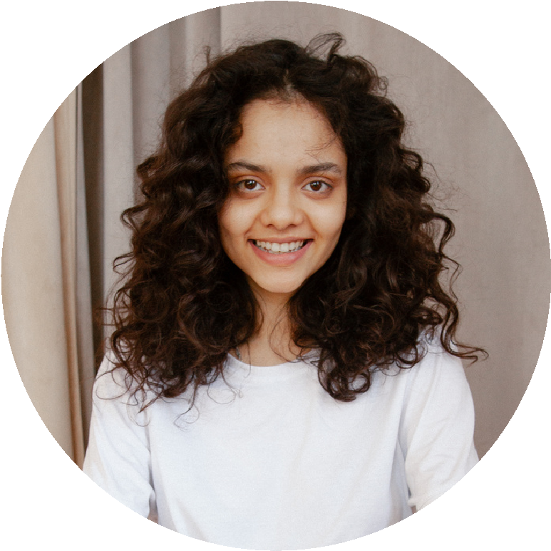

https://www.linkedin.com/i

n/rahul-kumar-9881a3256

https://github.com/9708994174

**VAISHALI CENTRAL PUBLIC SCHOOL**

Matriculation

2020

**HOBBIES**

Travelling

Listening Music

**PROJECTS**

University Management System

Portfolio

**CERTIFICATES AND CERTIFICATIONS**

Certification of completion in basic python

Certification of completion in HTML and Css

Certificate of completion of DCA

**PROFILE**

Computer Science

Engineering Student.

I consider my self a

responsible and orderly

person.

I am looking foward for

my first work

experience.

**CONTACT ME**

9708994174

kumar799024@gmail.com

Kuttupur,Vaishali,Patna,

Bihar

**NON TECHNICAL SKILLS**

Good listener

Team player

Adaptability

**EDUCATION**

**LOVELY PROFESSIONAL UNIVERSITY**

B-Tech Computer Science Engineering

**GURUKUL VIDYAPEETH SCHOOL**

*Intermediate*

*2021-2022*

**LANGUAGE**

Native Hindi.

English.

**TECHNICAL SKILLS**

PYTHON.

**RAHUL**

**KUMAR**

**Web Developer**

HTML and CSS

MICROSOFT EXCEL